Safeguarding (Child Protection) Policy
Somerset
Education Safeguarding Service
Updated July 2019 reflecting:
Keeping Children Safe in Education (September 2019)
Working Together to Safeguard Children (March 2018)
Somerset Safeguarding Partnership (previously the Somerset Safeguarding Children’s Board) policies and procedures

Date ratified by the Governing Body | 16.9.19
Review Cycle | Annual or when there is a change in statutory guidance or legislation
Review Date | September 2020

Contents
Introduction 3
Definition of safeguarding 3
Our commitment 3
Statutory responsibilities 4
The role of the Designated Safeguarding Lead (DSL) 4
The Deputy Designated Safeguarding Lead (DDSL) 5
What all staff should know 5
Staff Induction 5
Action to be taken if there are concerns in relation to safeguarding practices [Any school] and residential provision 5
Specific Responsibilities Relating to Residential Provision 6
Abuse and neglect (definitions) 7
Physical abuse 7
Neglect 7
Emotional abuse 7
Sexual abuse 8
Safeguarding in specific circumstances: 8
Children and the court system 8
Children Missing Education (CME) 8
Children with family members in prison 8
Child Sexual Exploitation (CSE) 8
Child Criminal Exploitation (CCE) 8
Child and Adolescent Mental Health: 9
Bullying [Any School] 9
Domestic abuse 9
Homelessness 9
Online Safety 9
Peer on Peer abuse 9
Preventing extremism 10
Private Fostering: 10
So-called ‘honour-based’ violence (including Female Genital Mutilation, Forced Marriage Breast Ironing) 11
Allegations of abuse made against teachers, other staff, Volunteers and Agency Staff: People in a Position of Trust 12
What staff should do if they have concerns about another staff member & Governor responsibility 12
Appendix A 14
Appendix B 18
Appendix C 19
Appendix D 20

Introduction
In the Croscombe and Stoke St Michael Primary Federation, we are committed to providing an environment that nurtures and transforms the lives of children and young people attending our schools and take seriously our responsibilities to safeguard and promote their welfare. In addition, we undertake our responsibilities to work in partnership with agencies as part of the wider, multi-agency, safeguarding system, always acting in the best interest of the child or young person where concerns are identified, in accordance with the Croscombe and Stoke St Michael Primary Federation Safeguarding (Child Protection) Policy and Procedures, statutory guidance and Somerset Safeguarding Partnership policies and procedures.

Personal sensitive information is processed in accordance with the Data Protection Act 2018 and Part 3, the General Data Protection Regulations (GDPR). Consent to share information will be sought unless we are required to share information where there are child protection concerns (and consent has been withheld) or we are requested to share information with other statutory agencies such as the police or children’s social care in pursuit of their enquiries in order protect and safeguard children and young people.

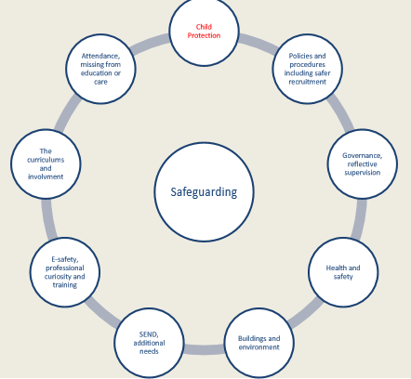
Definition of safeguarding
Safeguarding and promoting the welfare of children is defined in statutory guidance as: protecting children from maltreatment; preventing impairment of children’s health or development; ensuring that children grow up in circumstances consistent with the provision of safe and effective care; taking action to enable all children to have the best outcomes.

Safeguarding and promoting the welfare of children is everyone’s responsibility. In order to fulfil this responsibility effectively we ensure our approach is child centered, considering always, what is in the best interests of the child or young person.

Most children grow up in loving families and supportive communities and become independent, resilient adults. Wherever possible we want this for all children and young people in Somerset, so that they and their families can support themselves by engaging with and contributing to their local communities. In order to achieve this children, young people and their families should receive the right intervention as early as possible to tackle problems and prevent issues escalating. All practitioners will adopt an Early Help/Think Family approach meaning they look at the whole family situation and what needs to happen to improve that situation whether that means working with adults, children or the whole family

Our commitment
To safeguard and promote the welfare of children and young people through:
- The provision of a safe environment in which children and young people can learn
- Identifying concerns early and provide appropriate help and support for children and young people and their parents/carers to prevent concerns escalating to a point whereby intervention would be required under the Children Act 1989 and in accordance with the Somerset Effective Support for Children and Families, Thresholds for Assessment and Services guidance.

Glossary
- Reference to “staff” includes both education and support staff
- “Staff” or “members of staff” includes all paid staff irrespective of their role in the organisations and includes agency staff and volunteers
- SSP is an abbreviation for the Somerset Safeguarding Partnership (SSP) the new name for the Local Safeguarding Board (LSCB)

Statutory responsibilities
All action taken by [Any School] will be in accordance with:
Current legislation namely:
- The Children Act 1989 and 2004; Education Act 2002 and 2011; Education and Inspections Act 2006;

Statutory guidance and Advice namely:
- Working Together to Safeguard Children (2018) which sets out the multi-agency working arrangements to safeguarding and promote the welfare of children and young people
- Keeping Children Safe in Education (September 2019) which sets out what schools should do and sets out the legal duties with which school must comply with in order to keep children and young people safe
- Teacher Standards 2012 which sets out that teachers, including Headteachers, should safeguard children’s well-being and maintain public trust in the teaching profession as part of their professional duties
- Other specific guidance and advice issued by the DfE in relation to the wider safeguarding agency, e.g. behaviour, health and safety, bullying, e-safety and medical needs

The role of the Designated Safeguarding Lead (DSL)
Keeping Children Safe in Education (September 2019) requires each school to have a designated safeguarding lead (DSL) who has the status and authority with the to carry out the duties of the post including committing resources and where appropriate, supporting and directing staff. The provided advice and support to other staff on child welfare and child protection matters, take part in strategy discussions, inter-agency meeting (or support other staff to do so) and to contribute to the assessment of children and young people.

The Deputy Designated Safeguarding Lead (DDSL)
Supports the DSL in discharging their responsibilities and whilst they may deputise for the DSL the lead responsibility for child protection remains with the DSL. We have DSLs based at each school, but responsible across the federation.

Details of key safeguarding personnel can be found at Appendix D

Both the DSL and DDSL must complete single agency and multi-agency training to undertake the role which is provided by the Local Authority Education Safeguarding Service and Somerset Safeguarding Partnership. In addition, they will access DSL briefings, attend annual refresher training and remain up to date in relation to early help, safeguarding and child protection. More information about the roles and responsibilities of the DSL and DDSL can be found here

What all staff should know
All schools are required to issue Part One of Keeping Children Safe in Education (September 2019) - in full - to their staff and ensure that they have read and understood its contents. At Croscombe and Stoke St Michael Primary Federation , we are adopting this guidance and its contents across the whole organisation and whilst the language refers to “school” or “headteacher” it applies to both care and education provision provided at [Any School]. “School” should be interpreted to be Croscombe and Stoke St Michael Primary Federation and “headteacher” should be interpreted as “Executive Headteacher”
Part One can be accessed here

Staff Induction
As part of the induction process for new employees they will attend an induction briefing or if they commence part way through the year receive a one to one induction meeting with either the DSL DDSL that signposts staff to relevant safeguarding documentation including this policy and procedure, guidance for safer working practice, what to do if you’re worried a child may be abused and whistleblowing advice see Appendix A: Staff Induction Record

Action to be taken if there are concerns in relation to safeguarding practices
All staff, volunteers and agency staff should feel able to raise concerns about poor or unsafe practice and any potential failures in the safeguarding regime and know that such concerns will
be taken seriously by the senior leadership team and designated safeguarding leads. Should staff feel unable to raise concerns within the organisation advice and guidance has been produced to ensure that they are aware of how to raise such concerns externally see Appendix B: NSPCC Whistleblowing advice and information. Which is also available on the safeguarding notice board in the staff rooms. In addition, the Croscombe and Stoke St Michael Primary Federation whistleblowing policy is available via the website.

The Croscombe and Stoke St Michael Primary Federation concerns flowchart provides additional information about how to make a referral to children's social care, the LADO or to report concerns to the NSPCC advice line in instances where they have concerns about the organisation’s response to child protection, the conduct of staff or they do not feel that appropriate action has been taken in relation to concerns they have raised is at Appendix C: Concerns Flowchart

Abuse and neglect (definitions)
All staff should be aware that abuse, neglect and safeguarding issues are rarely standalone events that can be covered by one definition or label. In most cases, multiple issues will overlap with one another.

Abuse is the maltreatment of a child or young person; they may be abused or neglected through harm being inflicted or by parents or carers failing to prevent harm. Children and young people may be abused in a family or in an institutional or community setting by those known to them or by being targeted by others via the internet for example. They may be abused by an adult or adults or by another child or children. The following are the statutory definitions of abuse and neglect as set out in Working Together to Safeguard Children (2018) however, the ultimate responsibility to assess and determine the type category of abuse is that of the Police and Children's Social Care – our responsibility is to understand what each category of abuse is and how this can impact on the welfare and development of our children and where we have concerns that a child or young person may be at risk of abuse and neglect (one or more categories can apply) to take appropriate action as early as possible

Physical abuse: a form of abuse which may involve hitting, shaking, throwing, poisoning, burning or scalding, drowning, suffocating or otherwise causing physical harm to a child. Physical harm may also be caused when a parent or carer fabricates the symptoms of, or deliberately induces, illness in a child. Statutory guidance Safeguarding Children in whom Illness is Fabricated or Induced (2008) sets out a national framework within which agencies and professionals at local level – individually and jointly – draw up and agree upon their own more detailed ways of working together where illness may be being fabricated or induced in a child by a carer who has parenting responsibilities for them
Neglect: the persistent failure to meet a child’s basic physical and/or psychological needs, likely to result in the serious impairment of the child’s health or development. Neglect may occur during pregnancy as a result of maternal substance abuse. Once a child is born, neglect may involve a parent or carer failing to: provide adequate food, clothing and shelter (including exclusion from home or abandonment); protect a child from physical and emotional harm or danger; ensure adequate supervision (including the use of inadequate care-givers); ensure access to appropriate medical care or treatment. It may also include neglect of, or unresponsiveness to, a child’s basic emotional needs.
Emotional abuse: the persistent emotional maltreatment of a child such as to cause severe and adverse effects on the child’s emotional development. It may involve conveying to a child that they are worthless or unloved, inadequate, or valued only insofar as they meet the needs of another person. It may include not giving the child opportunities to express their views, deliberately silencing them or ‘making fun’ of what they say or how they communicate. It may feature age or developmentally inappropriate expectations being imposed on children. These may include interactions that are beyond a child’s developmental capability as well as overprotection and limitation of exploration and learning, or preventing the child participating in normal social interaction. It may involve seeing or hearing the ill-treatment of another. It may involve serious bullying (including cyberbullying), causing children frequently to feel frightened or in danger, or the exploitation or corruption of children. Some level of emotional abuse is involved in all types of maltreatment of a child, although it may occur alone.
Sexual abuse: involves forcing or enticing a child or young person to take part in sexual activities, not necessarily involving a high level of violence, whether or not the child is aware of what is happening. The activities may involve physical contact, including assault by penetration (for example rape or oral sex) or non-penetrative acts such as masturbation, kissing, rubbing and touching outside of clothing. They may also include non-contact activities, such as involving children in looking at, or in the production of, sexual images, watching sexual activities, encouraging children to behave in sexually inappropriate ways, or grooming a child in preparation for. Sexual abuse can take place online, and technology can be used to facilitate offline abuse. Sexual abuse is not sole perpetrated by adult males. Women can also commit acts of sexual abuse, as can other children.

Safeguarding in specific circumstances:
In addition to the above there are other areas of safeguarding that the organisation has to have due regard to. Annex A of Keeping Children Safe in Education (September 2019) highlights specific forms of abuse and safeguarding issues which staff who work with children and young people should read the following is a synopsis of the areas addressed but are not a fully replica of the guidance which can be accessed here

Children and the court system
Children may be required to give evidence in the criminal courts, either for crimes committed against them or for crimes they have witnessed. There are a range of guides to support child witnesses. In the civil courts children and young people may be involved in child arrangement hearing and the Ministry of Justice has launched an online child arrangement information tool detaining the dispute resolution service.

Children Missing Education (CME) All staff should be alert to children going missing as this can be a vital warning sign of a range of safeguarding risks, including abuse and neglect, sexual abuse or exploitation (Child Sexual Exploitation and Criminal), travel to conflict zones, Female Genital Mutilation (FGM), forced marriage. Early intervention is necessary to protect and safeguard a child or young person

Children with family members in prison are more likely to have poor outcomes, including poverty, stigma, isolation and poor mental health. More information to support schools and colleges can be found on the Nicco website

Child Sexual Exploitation (CSE) is child sexual abuse, whereby an individual or group takes advantage of an imbalance of power to coerce, manipulate or deceive a child or young person under 18 to engage in sexual activity (a) in exchange for something the victim needs or wants and/or (b) for the financial advantage or increased status of the perpetrator or facilitator

Child Criminal Exploitation (CCE) is geographically widespread form of har that is a often referred to as county lines, which involves drug networks or gangs that groom and exploit children and young people to carry drugs and money. A key indicator is that victims are often missing from home, care or education and trafficked for the purpose of transporting drugs.

Child and Adolescent Mental Health: Good mental health and resilience are fundamental to our physical health, our relationships, our education and to achieving our potential. DfE advice for schools in relation to Mental health and behaviour in schools (2018) which can be accessed here. This is non-statutory advice which clarifies the responsibility of the school, outlines what they can do and how to support a child or young person whose behaviour - whether it is disruptive, withdrawn, anxious, depressed or otherwise - may be related to an unmet mental health need. Whist it considers the school environment it is also relevant for work within our residential provision.

Bullying Croscombe and Stoke St Michael Primary Federation, has a separate Anti-Bullying policy which is accessible from the federation website. Further guidance is available from this link.

Domestic abuse, Domestic violence, Gender-based violence and violence against women and girls (VAWG), teenage relationship abuse: is defined as any incident or pattern of incidents of controlling, coercive, threatening behaviour, violence or abuse between those aged 16 or over who are or have been intimate partners irrespective of gender or sexuality. Exposure to domestic abuse or violence can have a serious, long lasting emotional and psychological impact on the development of children and young people. Further advice and guidance accessed via the NSPCC, Refuge and Safelives spotlight on young people and domestic abuse
Further resources relating to violence against women and girls (VAWG) can be accessed here

Homelessness or the being at risk of being made homeless is a significant risk for children or young people. The DSL should refer to the local housing authority at the earliest opportunity. The Homelessness Reduction Act 2017 places a new legal duty on English councils to provide meaningful help, including an assessment of need and circumstances. The DfE and the Ministry of Housing, Communities and local government have published joint statutory guidance on the provision of accommodation for 16 and 17 year old’s who may be homeless or require accommodation A series of fact sheets can be access here

Online Safety: Annex C of Keeping Children Safe in Education (September 2019) addresses the use of technology which can be a significant component of many safeguarding issues including CSE, CCE, radicalisation, sexual predation etc., whereby technology provides the platform that facilitates harm. Schools and colleges must adopt a range of effective safeguarding approaches that both safeguards and empowers children and young people to access support and remain safe online by reducing the risk of harm through the use of filters, monitoring and appropriate use policies for those accessing our IT system, whilst at the same time providing a safe environment in which children and young people can learn to keep themselves safe online.

Peer on Peer abuse: children and young people can abuse their peers which can take many forms, including but not limited to: bullying (including cyber bullying); sexual violence or harassment; physical abuse including hitting, kicking, shaking, biting, hair pulling or otherwise causing physical harm; sexting and initiating/hazing type violence or rituals.
Sexual violence and sexual harassment between children in schools and colleges: can occur between two children of any age and sex and occur through a group of children or young people sexually assaulting or harassing an individual or group of children.
It can also involve Upskirting which involves taking a picture under a person’s clothing without them knowing, with the intention of viewing their genitals or buttocks to obtain sexual gratification or cause the victim humiliation, distress or alarm. This is now a criminal offence
Further guidance is available here
Preventing extremism: Children and young people can be vulnerable to extremist ideology and radicalisation and forms part of schools and colleges safeguarding responsibilities, as set out in the Prevent Duty Extremism is the vocal or active opposition to our fundamental values and radicalisation refers to the process by which a person come to support terrorism and extremist ideologies associated with terrorist groups. Further information can be access below in relation to
Extremism Radicalisation Prevent

Private Fostering: is when a child under the age of 16 (under 18 if disabled) is cared for by someone who is not their parent or a 'close relative'. This is a private arrangement made between a parent and carer, for 28 days or more. Close relatives are defined as step-parents, grandparents, brothers, sisters, uncles or aunts (whether of full blood, half blood or marriage/affinity). A private foster carer may be a friend of the family, the parent of a friend of the child, or someone previously unknown to the child’s family who is willing to privately foster a child. [Any School] has a responsibility to refer to Children's Social Care of any private fostering arrangement we become aware of, in order for Children's Social Care to undertake an assessment to ensure the needs and welfare of the child or young person is being met and that adults caring for them have access to advice and support.

Special Education Needs and disabilities: There’s a concern sometimes that, for children with SEN and disabilities, that their SEN or disability needs are seen first, and the potential for abuse second. If children are behaving in particular ways or they’re looking distressed or their behaviour or demeanour is different from in the past, our staff should think about that being a sign of the potential for abuse, and not simply see it as part of their disability or their special educational needs.

The Governing Body
The Governing body will ensure that they comply with their duties under legislation. They will also have regard to this guidance to ensure that the policies, procedures and training in the provision are effective and comply with the law at all times.

The responsibilities placed on governing bodies and proprietors include:

- Contributing to ensure the provision is carrying out inter-agency working, which includes providing a coordinated offer of early help when additional needs of children are identified.
- Ensuring that an effective child protection policy is in place, together with a staff behaviour code of conduct policy and behaviour policy.
- Ensuring staff are provided with Part One of Keeping Children Safe in Education (DfE 2019) –and are aware of specific safeguarding issues.
- Ensuring that staff induction is in place with regards to child protection and safeguarding.
- Appointing an appropriate senior member of staff to act as the Designated Safeguarding Lead.
- Ensuring that all of the Designated Safeguarding Leads (including deputies) undergo formal child protection training every two years (in line with SCSB guidance) and receive regular (annual) safeguarding refreshers (for example via e-bulletins, meeting other DSLs, or taking time to read and digest safeguarding developments).
- Prioritising the welfare of children and young people and creating a culture where staff and volunteers are confident to challenge senior leaders over any safeguarding concerns.
- Ensuring that children are taught about safeguarding in an age appropriate way.
- Ensuring appropriate filters and appropriate monitoring systems are in place to safeguard children from potentially harmful and inappropriate online material
- Having a senior board level lead to take leadership responsibility for the organisation’s safeguarding arrangements.
- Ensure scrutiny and effectiveness of the single central record and child protection recording is undertaken.
- Ensure safeguarding is regularly discussed and outcomes recorded at Governor meetings.
- Ensure the requirements of The Governor’s Safeguarding Audit Section 175 are met and actions when needed completed in a timely way

Looked after children: The staff have the necessary skills and understanding to keep looked after children safe. Appropriate staff have information about a child’s looked after legal status and care arrangements, including the level of authority delegated to the carer by the authority looking after the child. The designated teacher for looked after children and the DSL have details of the child’s social worker and the name and contact details of the local authority’s virtual head for children in care.

So-called ‘honour-based’ violence (including Female Genital Mutilation, Forced Marriage Breast Ironing) encompasses incidents or crimes which have been committed to protect or defend the honour of the family or community. All forms of honour based violence (HBV) is abuse, regardless of the motivation and should be handled and escalated as such. There are specific mandatory reporting duties for teachers to report to the police where they discover (either through disclosure or visual evidence) that FGM appears to have been carried out on a girl under 18.
Additional guidance and publications
FGM: Mandatory reporting procedural information can be accessed here
FGM Fact sheet can be access here
Forced Marriages: Multi- agency guidelines(2014) pages 35 and 26 pertain to schools can be accessed here along with statutory guidance (2014) which can be access here

Allegations of abuse made against teachers, other staff, Volunteers and Agency Staff: People in a Position of Trust
Working Together to safeguard Children (March 2018) states that organisations should have in place clear policies in line with those from the Somerset Safeguarding Partnership to manage allegations against people who work with children and young people. Such policies should make a clear distinction between an allegation, a concern about the quality of care or practice or a complaint. Full details are available here

In addition, Keeping Children Safe in Education (September 2019) Part Four, sets how allegations may indicate that a person would pose a risk of harm if they continue to work in regular or close contact with children in their present position, or in any capacity in a school or college under the age of 18 years. Part 4 of the Keeping Children Safe in Education (September 2019) which can be accessed here

An allegation may relate to a person who works with children who has:
- behaved in a way that has harmed a child, or may have harmed a child
- possibly committed a criminal offence against or related to a child or
- behaved towards a child or children in a way that indicates they may pose a risk of harm

The Croscombe and Stoke St Michael Primary Federation, Management of Allegations policy and procedure is available on the website (Phone Somerset Direct on 0300 123 2224 for a referral).

What staff should do if they have concerns about another staff member
If any member of staff, volunteer or agency staff have concerns relating to an individual’s conduct or behaviour, whether they be a colleague, member of the management or senior leadership team, they should refer their concerns to the designated safeguarding lead or the Headteacher.

Where concerns or allegations relate to the Headteacher, these should be referred to the chair of governors

Staff Code of Conduct; In addition to the Safeguarding and Child Protection policy, We have a staff Code of Conduct that outlines an acceptable level of staff behaviour. During their induction training, new staff will be given and have read: • Staff Code of Conduct (inc. use of social media, and the Position of Trust Offence) • The school’s Safeguarding and Child Protection policy • Keeping Children Safe in Education (2018) (Part One and Annex A) • Behaviour Policy • Procedures for children missing education.

Appendix A

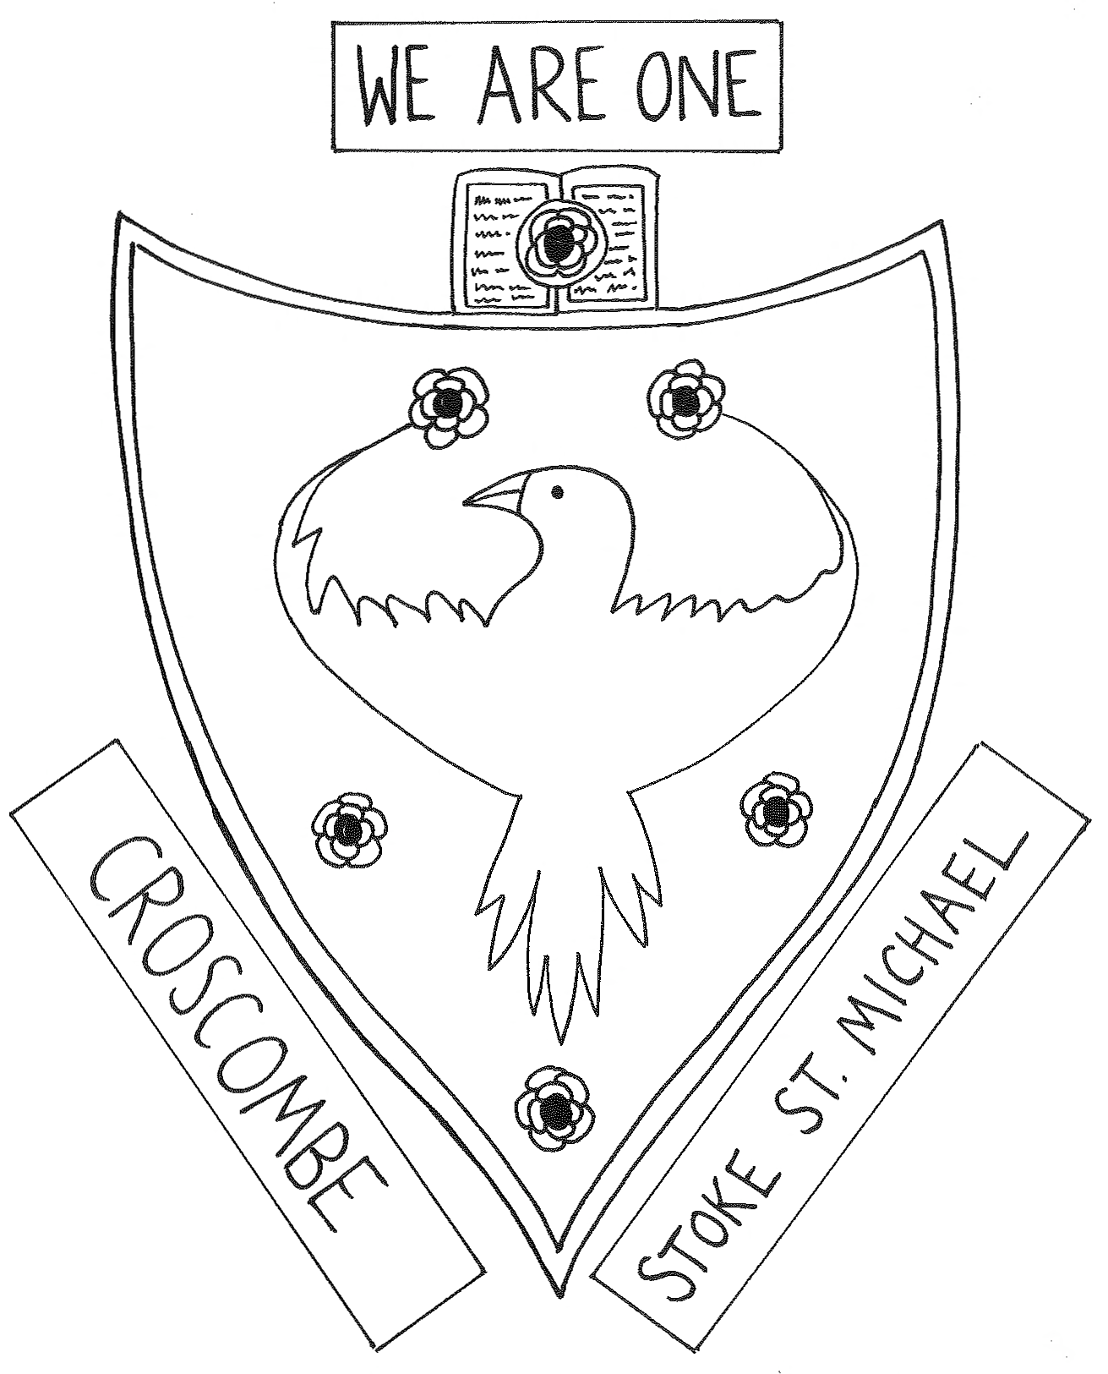
Employees
Safeguarding Induction

Staff Member:
Name and Role:

Date of Commencement:
Inductor:
Name and Role
Date of Induction:

Signed by Inductee:

Signed by Inductor:

Notes of guidance – to be removed when adopted by the School
Keeping Children Safe in Education (2019) states: ALL staff should be aware of systems within their school or college which supports safeguarding, and these should be explained to them as part of staff induction. This should include the:
- Safeguarding (Child Protection) policy
- Behaviour policy
- Staff behaviour policy (code of conduct)
- Safeguarding response to child who go missing from education and
- The role of the designated safeguarding lead (including the identity of the DSL and Deputy

Agenda:
Welcome to the Croscombe and Stoke St Michael Primary Federation
Outline of the induction meeting
  - Croscombe and Stoke St Michael Primary Federation Vision and Ethos
  - What is Safeguarding (Child Protection)
  - What safeguarding means for children or young people at Croscombe and Stoke St Michael Primary Federation
  - Voice and influence
  - Action to be taken if you have a concern

Croscombe and Stoke St Michael Primary Federation Vision and Ethos

Vision and Aims
Vision
Our vision is to provide an education that meets the needs of every child spiritually, emotionally, academically and physically in a peaceful and caring environment. At Croscombe, it is ensured that this is underpinned by our Christian foundation.
Aims
Our schools aim to:
- Provide an inclusive environment in which pupils and staff can feel valued and secure, through the practice of values such as compassion, respect, tolerance, forgiveness and friendship.
- Nurture open minded, imaginative, curious and confident individuals who are well-prepared for their next stage in life.
- Develop each child's esteem, self-discipline and awareness of the opinions and values of others.
- Enrich the whole curriculum so that all children can access and enjoy a variety of creative and cultural experiences.
- Foster in each child an appreciation of their role within their community and the wider world, including their responsibility to care for the environment.

In addition, Croscombe School aims to promote an inclusive Christian ethos that will engage the development of the spiritual and moral needs of each child through the curriculum, school policies and close links with the church.

Ethos Statement
Recognizing the historic foundation, the schools will preserve and develop the religious character of Croscombe Church of England Primary School in accordance with the principles of the Church of England and in partnership with the Church at parish and diocesan level.
The schools aim to serve their communities by providing an education of the highest possible quality and, for Croscombe Church of England Primary, within the context of Christian belief and practice. An understanding of the meaning and significance of faith and promotion of Christian values will be encouraged through the experience offered to pupils at Croscombe Church of England Primary.
Characteristics
This means that Croscombe CEVA Primary School will endeavour to be a community of learners through Christian care, collaboration, curiosity and contribution:
- caring for others, making them welcome, being friendly, helping others, considering others and their feelings;
- working together cooperatively, sharing ideas, taking turns, listening to others, being prepared to lead and to follow;
- looking out for others, being interested in God, life and the world;
- being willing to help, answer questions and try new ideas with confidence.

What is Safeguarding (Child Protection)
Safeguarding is an overarching term used to ensure that the welfare of children and young people is paramount, and they are protected from abuse and neglect. We all have a statutory duty to safeguard and promote the welfare of children. This means protecting children and young people from abuse and neglect; preventing impairment of health or development; ensuring they are growing up in circumstances consistent with the provision of safe and effective care and taking action to enable all children and young people to have the best life chances.

Every member of staff, irrespective of their role in the organisation, has a responsibility to keep children or young people safe and to take appropriate action whenever they hear, observe or are told information that could impact on their welfare and safety.

Child protection is the statutory threshold for intervention in family life whereby a child or young person is suffering or at risk of significant harm. As an organisation [Any School] has a number of statutory responsibilities that must be fulfilled which are set out in legislation and statutory guidance.

You have been issued with Part 1 of Keeping Children Safe in Education (September 2019) and you will have been asked to read the document ahead of today’s induction. Have you had an opportunity to do so? Do you have any questions?

What Safeguarding means for children or young people at [Any School]
At Croscombe and Stoke St Michael Primary Federation we expect our staff to exercise high standards of behaviour and provide high quality professional support to our children. It is therefore important that we all understand that the nature of our work and the responsibilities related to it, which places us in unique position of trust. During the course of your induction you will have the opportunity to access a range of training that will provide you with the knowledge and skills you need to do your job. In addition, you will be required to read a number of different policies and procedures that will provide you with contextual information and guidance.

All staff, irrespective of their role in the organisation, have a responsibly to ensure that illegal, unsafe, unprofessional or irresponsible behaviour exhibited by staff is challenged and reported. It is always difficult to raise concerns about a colleagues’ behaviour, but you must discuss any concerns with the designated or deputy safeguarding lead.

If you do not feel you can raise concerns within the organisation then you can access the NSPCC Whistleblowing helpline on 0800 028 0285 between 8 a.m. and 8 p.m. or email help@nspcc.org.uk

You should familiarise yourself with the following polices which are available on the Safeguarding Notice Board (Staff Room) and on the School Website:

- Guidance on safer working practice for those working with children and young people in education settings (May 2019) Croscombe and Stoke St Michael Primary has adopted this as our staff code of conduct which is available in the staff room on the safeguarding notice board

- What to do if you’re worried a child is being abused (DfE March 2015) advice for practitioners

- Croscombe and Stoke St Michael Primary Safeguarding (Child Protection) Policy and Procedures can be accessed in the school office and on the school website.m As can Croscombe and Stoke St Michael Primary Behaviour policy and Children Missing Education procedures.

Voice and influence
When working with children and young people communication is crucial, especially in relation to safeguarding. Communication is a two-way process and doesn’t just relate to a child’s ability to communicate via speech therefore, we need to approach communication in its broadest terms, considering body language, gestures, behaviour and presentation. We must also support our children to make positive choices.

Action to be taken if you have a concern about the welfare of a pupil or the conduction/actions of a member of staff or visitor to Croscombe and Stoke St Michael Primary
You should discuss your concerns, observations or any information that may impact on the welfare of a child with a designated or deputy safeguarding lead. The flowchart overleaf has been developed to offer you guidance on what you should do. It is not intended to cover all eventualities, but it aims to provide a framework for action.
What is important is that you take action and raise your concerns, the designated or deputy safeguarding lead may hold other relevant information, but your information may be new and important - the final part of the information jigsaw.

Updated July 2019

Appendix B
Date of issue July 2019

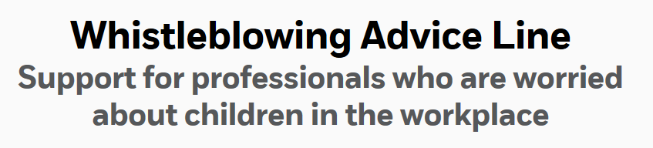
The NSPCC whistleblowing Advice Line offers free advice and support to professionals with concerns about how child protection issues are being handled in their own or another organisation.
What is whistleblowing?
Whistleblowing is when someone raises a concern about a dangerous or illegal activity or any wrongdoing within their organisation.
Raising a concern is known as “blowing the whistle” and is a vital process for identifying risk to children, young people and vulnerable adults. In recent years there have been several high profile cases of institutional abuse which have come to light as a result of whistleblowing.
Sharing information or talking through a concern can be the first step to helping an organisation identify problems, improve practice and safeguard the welfare of children, young people and vulnerable adults.
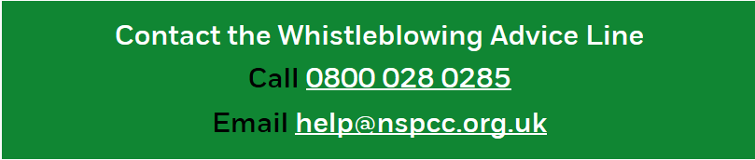

The government website www.gov.uk also has valuable information for whistleblowers in relation to their rights, support and who to tell. This can be accessed here:

Appendix C

Appendix C
Action to be taken where there are concerns about the welfare of a child or young person or the conduct/actions of Staff or Visitors
Insert School Logo
Updated July 2019
General Information and Advice
Always maintain an attitude of ‘it could happen here’: Learning lessons from Serious Case Reviews e.g. Daniel Pelka and Nigel Leat

Always act in the best interests of the child or young person: the welfare of the child is paramount Children Act 1989

Be alert to the signs of abuse and neglect supporting documents include:
Croscombe and Stoke St Michael Primary Safeguarding (Child Protection) Policy & Procedures: Part One: Keeping Children Safe in Education (September 2019):
What to do if you’re worried a child is being abused (DfE March 2015) Advice for Practitioners: Working Together to Safeguard Children (2018)
These can be accessed on the [Any School] website and the safeguarding notice board in the staff room

If, a child or young person is in immediate danger or is at risk of significant harm
Anyone can make a referral to Children’s Social Care and/or the Police (but the Designated Safeguarding Lead (DSL) should be informed if a referral has been made). Contact details: Insert Somerset details Office Hours telephone number : Emergency Duty Team (EDT) outside office hours, weekends or bank holidays telephone number or contact the Police on 999

If you have a concern relating to dangerous or illegal activity or any wrongdoing within the organisation and you do not feel you can raise a concern directly you can contact the NSPCC Whistleblowing helpline 0800 028 0285 – line is available from 8:00 AM to 8:00 PM, Monday to Friday or Email: help@nspcc.org.uk

How to report child welfare or child protection concerns at [Any School]
Immediate Concerns and/or immediate action is required

Child Welfare
Discuss your concerns with your immediate line manager
Or
Discuss your concerns with the Designated or Deputy Safeguarding Lead (DSL)

You must act to safeguard

Concerns relating to the conduct or actions of a staff member: The DSL will liaise with the Headteacher or you can refer your concerns directly. If concerns relate to Headteacher the Chair of Governors must be notified. All allegations will be investigated following statutory guidance and Somerset Safeguarding Partnership procedures by the Local Authority Designated Officer (LADO)
Safeguarding/Child Protection Concerns
The DSL will consider what information is already known consider indicators of risk and following multi-agency guidelines take appropriate action

Appendix D

Early Years Provision.

Working Together 2018 states -
- Early years providers have a duty under section 40 of the Childcare Act 2006 to comply with the Safeguarding and Welfare Requirements of the Early Years Foundation Stage.
Keeping Children Safe in Education 2018 states –
- The Early Years Foundation Stage Framework (EYFS) is mandatory for all early years providers. It applies to all schools that provide early years provision including maintained nursery schools.
The Early Years Foundation Stage states –
- Schools are not required to have separate policies to cover EYFS requirements provided the requirements are already met through an existing policy. Where providers other than childminders are required to have policies and procedures as specified below, these policies and procedures should be recorded in writing.

- Providers must be alert to any issues of concern in the child’s life at home or elsewhere. Providers must have and implement a policy, and procedures, to safeguard children. These should be in line with the guidance and procedures of the relevant Local Safeguarding Children Board (LSCB). The safeguarding policy and procedures must include an explanation of the action to be taken when there are safeguarding concerns about a child and in the event of an allegation being made against a member of staff and cover the use of mobile phones and cameras in the setting.

Early Years Providers must be complaint with the Safeguarding and Welfare Requirements
Below is the link to the EYFS
https://www.gov.uk/government/publications/early-years-foundation-stage-framework--2

- As an appendix to this policy, we ensure that we are compliant with all the Safeguarding and Welfare Requirements of the Early Years Foundation Stage 2017 by adopting the following:
- We have a mobile phone and camera policy in place within the provision that details the procedure for use of these devices. This covers the use of Mobile Phones and Cameras in the setting and on visits and includes the settings procedures with regards to mobile phones and cameras for all staff, volunteers and visitors.

Details of the Designated Safeguarding Lead and Deputy/Deputies

Key Safeguarding staff

Name | Designation | Contact details
Steve Heath | Headteacher | sheath@educ.somerset.gov.uk
Nick Cramp | Chair of Governors | ncramp@educ.somerset.gov.uk
Di Levien | Nominated Safeguarding Governor | dlevien@educ.somerset.gov.uk
Steve Heath | DSL | sheath@educ.somerset.gov.uk
Mel Vincent  Bill Moore | DDSL | mvincent@educ.somerset.gov.uk  wmoore1@educ.somerset.gov.uk
 | Pre-school Leader

