**Stoke St Michael County Primary School**

**Little Roots @ Stoke**

Moonshill Road

Stoke St Michael

# Radstock

BA3 5LG

**School Office:** 01749 840470

**Little Roots @ Stoke:** 01749 840470/07565 931718

**E-mail:** stoke-st-michael@educ.somerset.gov.uk

**Acting Head of School: M****rs M Vincent**

**6th April 2020**

Dear Parent/carer

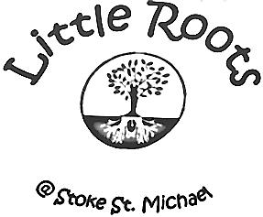



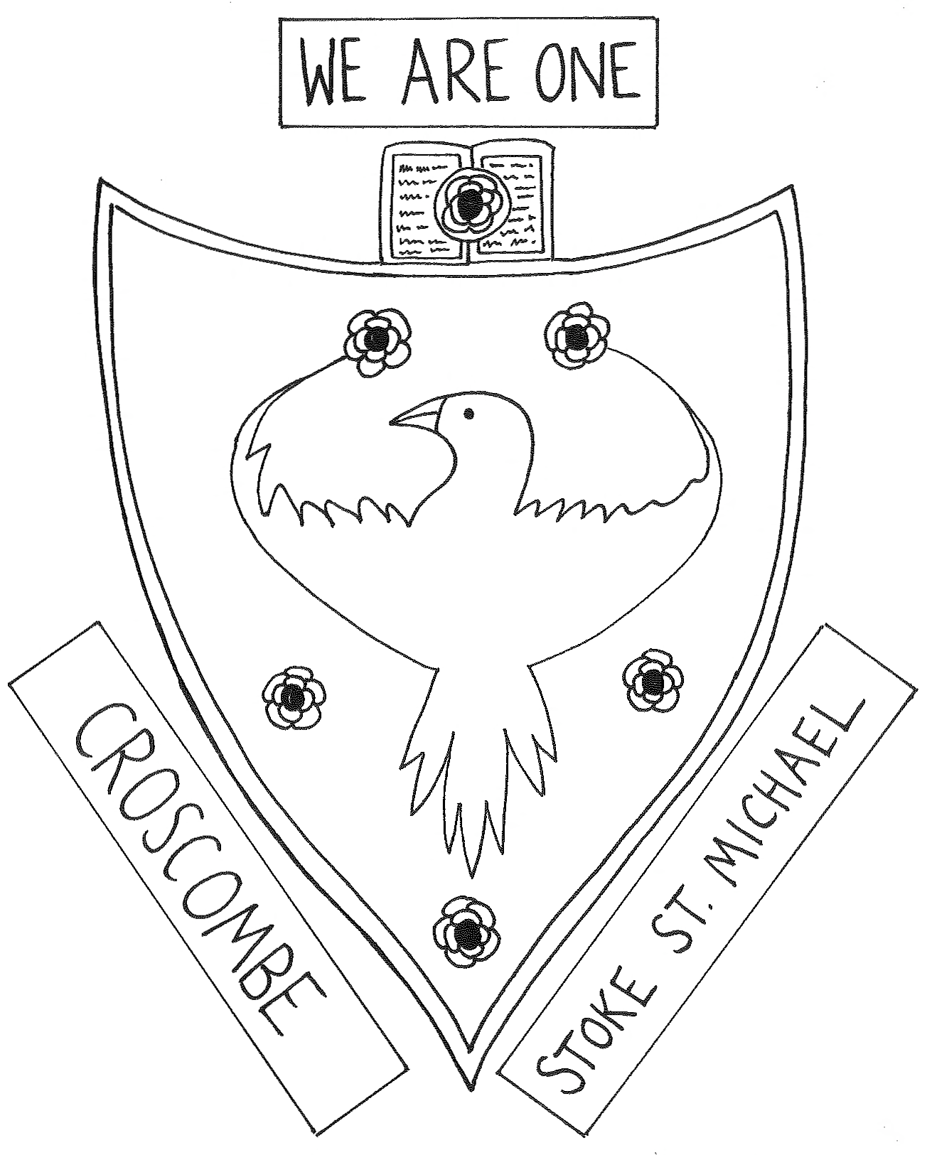

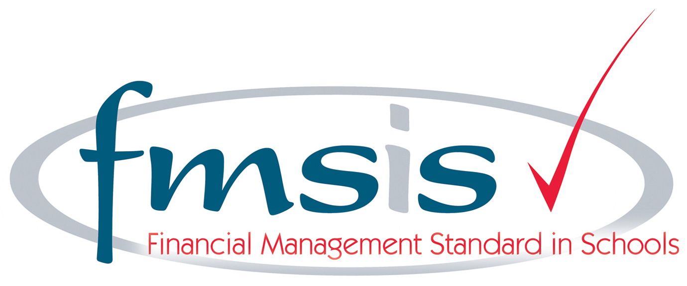****



We are delighted to let you know that (although still in working progress) we have launched our new federation website.

Please click the link below to see:

<http://croscombestokefederation.co.uk/>

|  |
| --- |
| [Croscombe and Stoke St. Michael School Federation - State Schools for Boys and Girls](http://croscombestokefederation.co.uk/)  Croscombe and Stoke St. Michael School Federation is a federation of state schools. Our federation is for Boys and Girls Aged 4 - 11 Years Old.  croscombestokefederation.co.uk |

Home learning has now been uploaded here on the federation page where you will find your child's class and all the attachments you will need alongside an explanation letter dated 03.04.20 from your child's teacher. We will upload another set on 17.04.20 at the start of the new Summer term. Please don't feel you need to complete it all. Just choose some activities that suit you and your child. Likewise if you would like more, please do not hesitate to get in touch with us via the school office emails and we will accommodate you to the best we can.

 A huge thank you to <https://www.mercerdesign.co.uk/> for their hard work in getting this up and running for our federation.

We hope you enjoy the new evolving website,

Have a Happy Easter staying safe!

Best wishes,

Mel Vincent and Bill Moore

Acting Heads of Schools